3D Object Representation
Graphics scenes can contain trees, flowers , clouds rocks water, rubber, paper , bricks etc.

Polygon and quadratic surfaces provide precise descriptions for simple Euclidean objects such as polyhedrons ellipsoid.

Polygon Surfaces

3-D graphics object is a set of surface polygons that enclose the object interior
A polygon mesh is a set of connected polygonally bounded planar surfaces
Equation of plane is Ax + By + Cz + D = 0
A polygon mesh is a collection of edges, vertices and polygons connected such
that each edge is shared by at most two polygons.

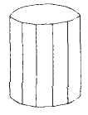

Polygon Tables
Polygon data tables can be organized into two groups: geometrical and attribute tables
Geometric data tables contain vertex coordinates and parameters to identify the spatial orientation of polygon surfaces
Attribute information for an object includes parameters specifying the degree of transparency of object and its surface reflectivity and texture characteristics.

A convenient organization for storing
geometric data is to create three lists:
i. a vertex table
ii. an edge table
iii.a polygon table

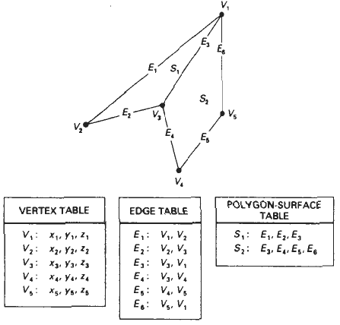

Plane Equations
The equation for a plane surface can be expressed as
Ax + By + Cz + D =0 …….(i)
Where, (x,y,z) is any point on the plane- coefficients ABCD are constants describing the spatial properties of the plane

For solving ABCD consider three successive polygon vertices (x₁, y₁, z₁), (x₂, y₂, z₂), (x₃, y₃, z₃)
So equation (i) is modified to,
A x_{k} + B y_{k} + C z_{k} = -1 …….(ii) k = 1,2,3
D D D

Using Cramers rule,
A = 1 y₁ z₁ B = x₁ 1 z₁ C = x₁ y₁ 1 D = x₁ y₁ z₁
1 y₂ z₂ x₂ 1 z₂ x₂ y₂ 1 x₂ y₂ z₂
1 y₃ z₃ x₃ 1 z₃ x₃ y₃ 1 x₃ y₃ z₃

Expanding Determinants,
A = y₁ ( z₂ - z₃ ) + y₂ ( z₃ – z₁ ) + y₃ ( z₁ – z₂ )
B = z₁ ( x₂ - x₃ ) + z₂ ( x₃ – x₁ ) + z₃ ( x₁ – x₂ )
C = x₁ ( y₂ - y₃ ) + x₂ ( y₃ – y₁ ) + x₃ ( y₁ – y₂ )
D = -x₁ (y₂z₃ – y₃z₂ ) - x₂ (y₃z₁ – y₁z₃ ) - x₃ (y₁z₂ – y₂z₁ )

Plane equations are used to identify the position of spatial points relative to the plane surfaces of an object. For any point (x,y,z) not on plane with parameters ABCD we have
Ax + By + Cz + D = 0

We can identify the point as either inside or outside the plane surface according to the sign( + or -) of
Ax + By + Cz + D

If Ax + By + Cz + D < 0 then the point (x,y,z) is inside the surface
If Ax + By + Cz + D > 0 then the point (x,y,z) is outside the surface

Polygon Meshes
Some graphics packages (PHIGS programmer’s Hierarchical Interactive Graphics Standard) provide several polygon functions for modeling objects.
One type of polygon mesh is the triangle strip

It produces n – 2 connected triangles, given the
coordinates for n vertices.

Another similar functions the quadrilateral
mesh that generates a mesh of (n-1)(m-1) quadrilaterals,
given the coordinates for an n by m array of vertices
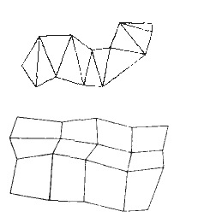

When polygons are specified with more than 3 vertices, it is possible that the vertices may not all lie in one plane.

This can be due to numerical error or errors in selecting coordinate positions for the vertices

Remedies:
i. Simply divide the polygons into triangles
ii. Approximate the plane parameters ABC and project in same plane (i.e. approximate A to yz plane, B to
xz plane, C to xy plane etc)

High quality graphics systems typically model objects with polygon meshes and set up a database of geometric and attribute information to facilitate processing of the polygon facets.

Curved Surfaces and Lines
Display of 3D curved lines and surfaces can be generated from an input set of mathematical functions (spheres, ellipsoid etc) defining the objects or from a set of user specified data points.

Spline representations are examples of generating curves and surfaces. These are commonly used to design new object shapes , to digitize drawings and to describe animation paths.

Curve fitting methods are also used to display graphs of data values by fitting specified curve functions to the discrete data set, using regression techniques such as the least square methods.

